Reese King
Public Relations Specialist
Miami, FL 33130 reese.king@email.com
(000) 000-0000
LinkedIn | Portfolio

Public relations specialist with six years of experience crafting media strategies, managing brand messaging, and coordinating press outreach. Proven track record in securing media coverage, boosting engagement, and enhancing reputation for lifestyle and tech brands.

PROFESSIONAL EXPERIENCE

Public Relations Specialist
Velocity Communications | Miami, FL | April 2019 - Present
Generated 40+ media placements annually in national outlets, increasing brand visibility and audience engagement
Developed strategic press kits and messaging for six product launches, leading to 130% increase in mentions
Managed crisis communications during product recalls, maintaining trust and controlling narrative

Communications Coordinator
Urban Infiuence | Orlando, FL | June 2017 - March 2019
Drafted press releases, social copy, and internal communications aligned with client brand voice
Tracked media trends and competitor activity, informing monthly strategy shifts and adjustments
Built relationships with key journalists, resulting in higher open and response rates for outreach
EDUCATION

Bachelor of Arts (B.A.) in Public Relations
Florida State University | Tallahassee, FL | May 2017

KEY SKILLS
Crisis communication - Expert Media pitching - Proficient
Press release writing - Competent Social media strategy - Amateur Stakeholder messaging - Beginner

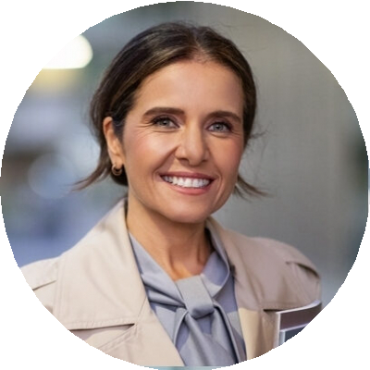
CERTIFICATIONS

Accredited in Public Relations (APR)
PRSA | 2022

HubSpot Content Marketing Certiication
2023

